OPERATING SYSTEMS LAB

Practical Quiz — Linux Terminal & File Management
Student Name: Uzma Mumtaz | Roll No.: _I-SE9244426
Duration: 40 minutes | Total Marks: 20

Instructions
- Perform all tasks on a Linux terminal. Use your own roll number in the main folder name.
- Write the commands you used in the spaces provided and show the final output to the instructor.
- Do not use a graphical file manager. Each task builds on the previous task.
- Work inside your home directory; do not use sudo or change files outside your quiz directory.

Scenario
You are helping organize the files for a university Operating Systems lab. Create and maintain a small directory structure, record student data, find a specific entry, and control access to a report using Linux commands.

Task 1 — Create the Workspace (4 marks)
Create a directory named OS_Quiz_<RollNo> in your home directory. Inside it, create two directories named Reports and Backup. Navigate into the main quiz directory.
Commands / observations:
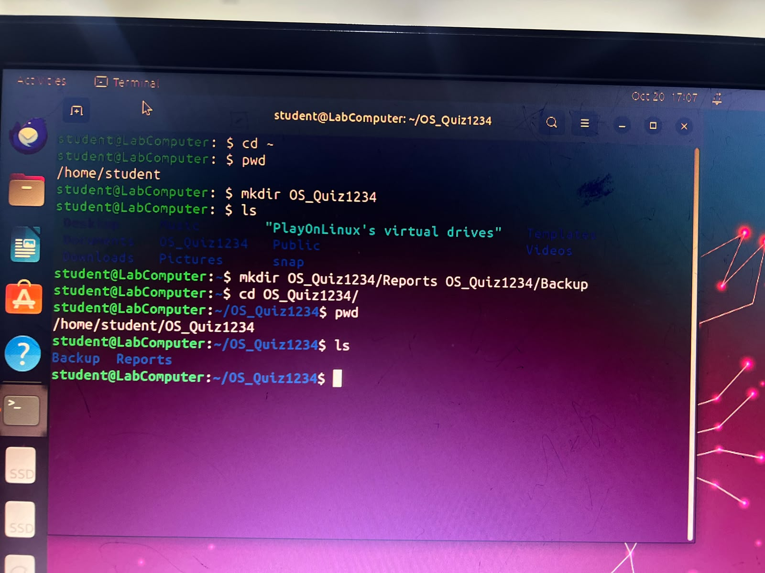

Task 2 — Create and Inspect a File (4 marks)
Inside Reports, create a file named students.txt containing the following three lines exactly:
Ali 85
Sara 92
Ahmed 76
Display the file contents in the terminal.
Commands / observations:

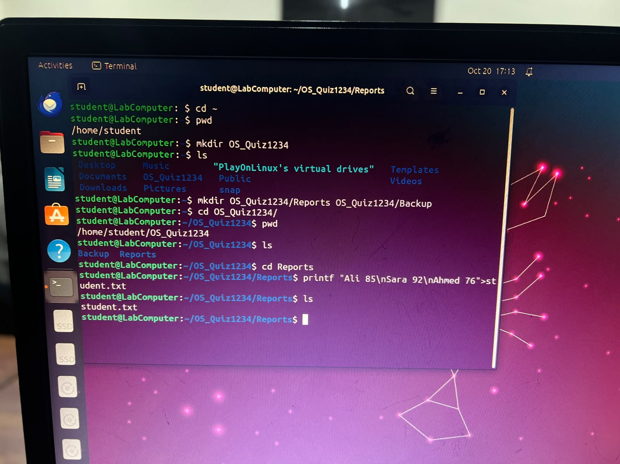

Operating Systems Lab | Practical Assessment

Task 3 — Copy and Rename (4 marks)
Copy students.txt from Reports to Backup. Rename the copied file in Backup to students_backup.txt. Show the files in Backup using a terminal command.
Commands / observations:

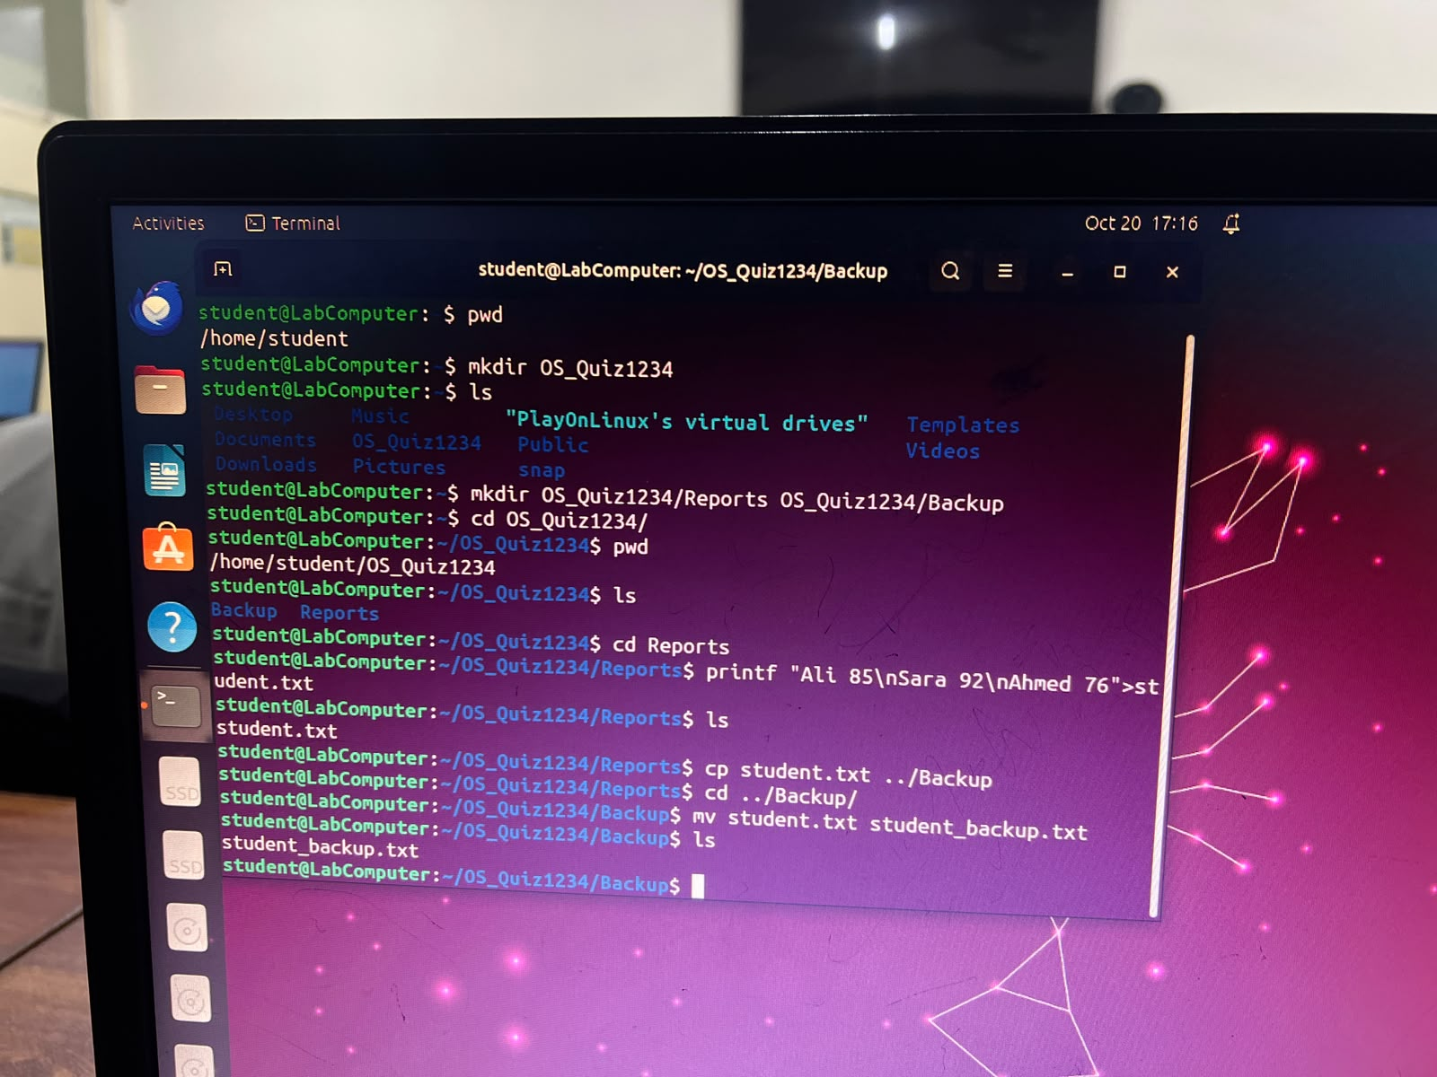

Task 4 — Search and Filter (4 marks)
Using a Linux text-search command, display only the line containing Sara from Reports/students.txt. Then display a detailed listing of the Reports directory.
Commands / observations:

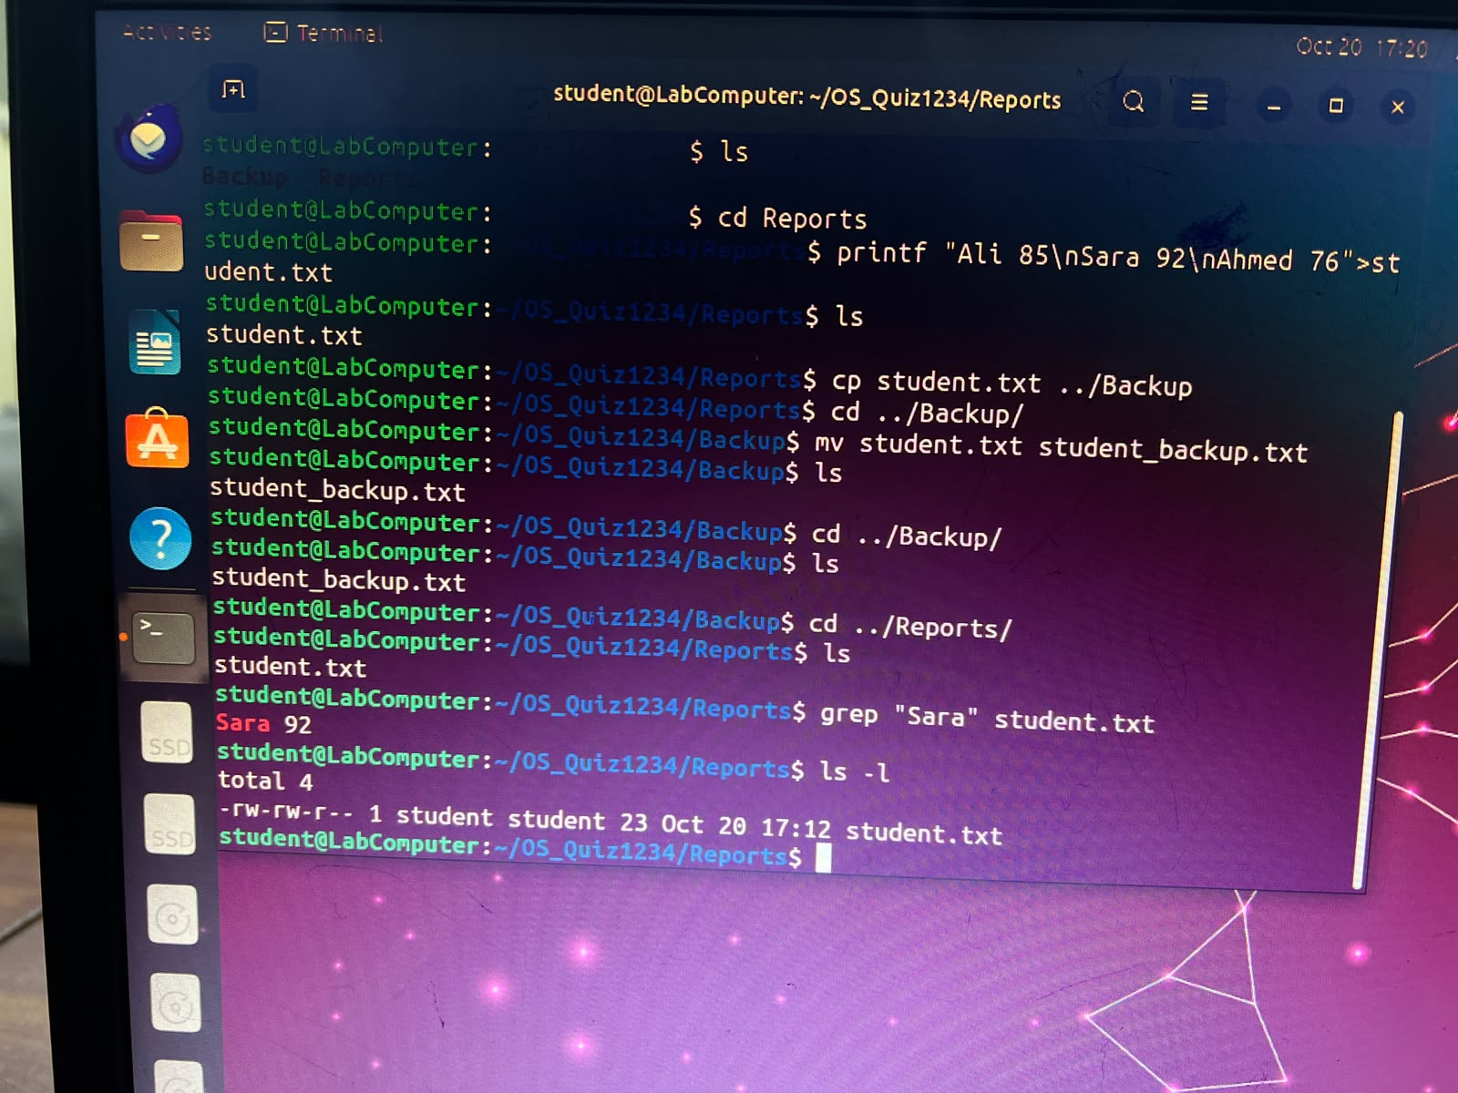

Task 5 — Set Permissions and Verify (4 marks)
Change the permissions of Reports/students.txt so that its owner can read and write it, while group and others can only read it. Verify the resulting permissions using a Linux command.
Commands / observations:

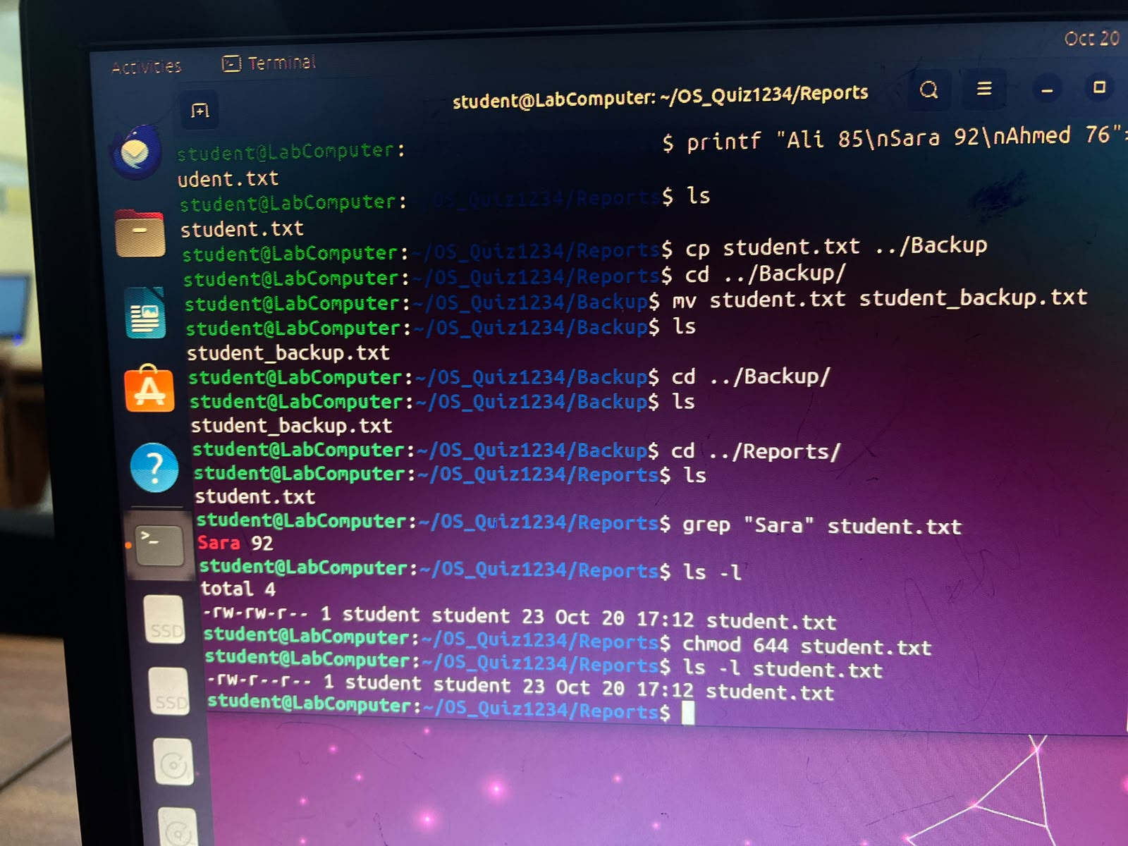

Submission Checklist
Show your final directory tree (or equivalent recursive listing), the search result, and file permissions to the instructor.
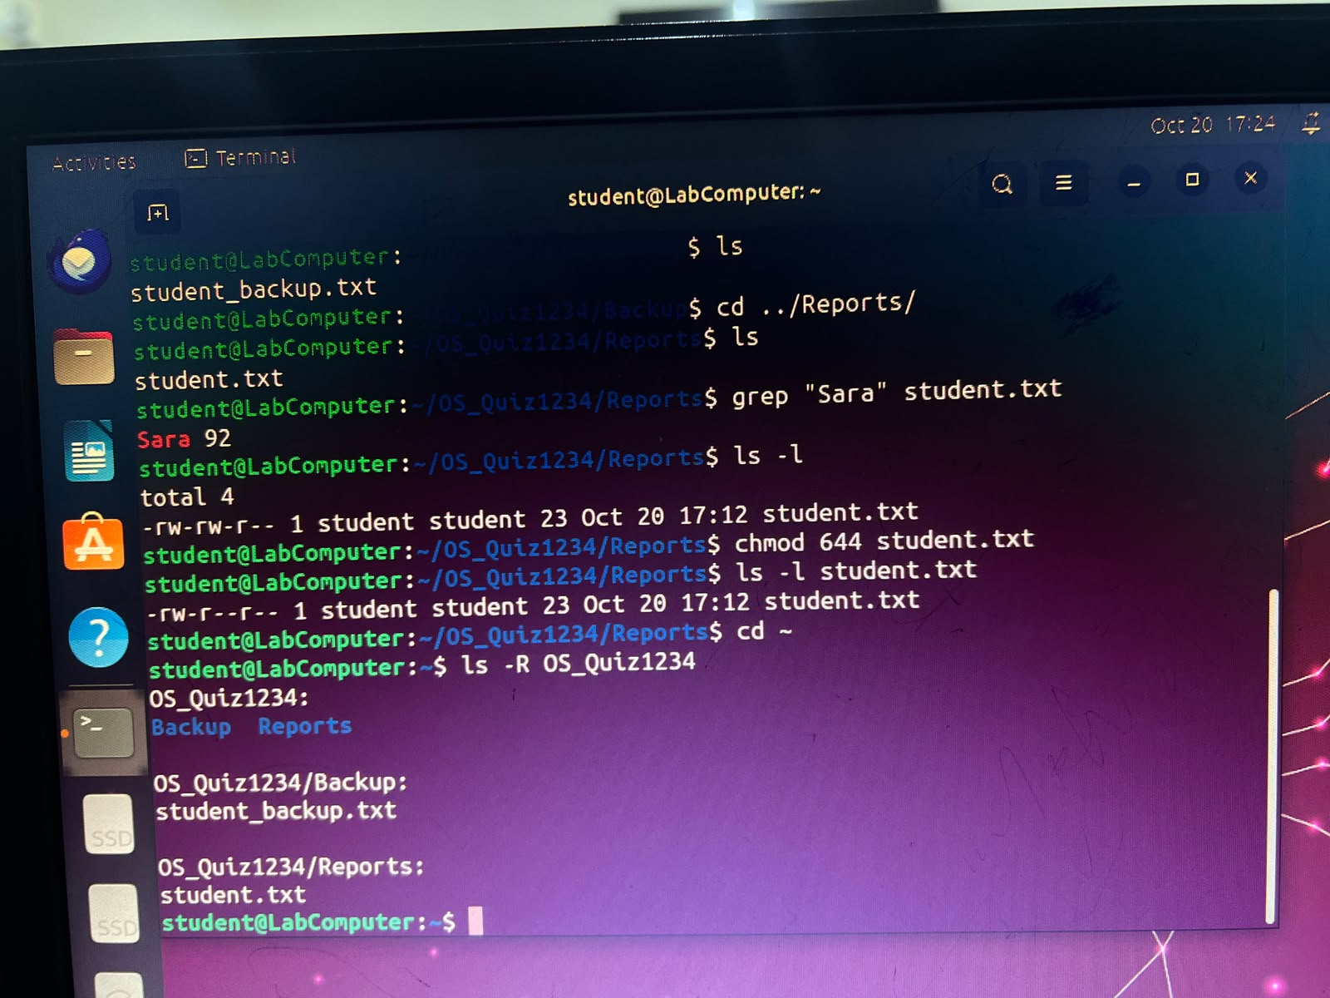

Operating Systems Lab | Practical Assessment

